This guide is designed to walk you through how to conduct a web load test using the provided Artillery and Playwright scripts. Just follow these simple steps.

# Step 1: Setup and Preparation

1. **Download and Unzip**: First, please go to the shared folder, find the specified compressed file, and download it. Once downloaded, extract its contents to a location of your choice.

<https://drive.google.com/drive/folders/1rAbGyOJQkbpsakuXv1L66vsJ7F-n7uLy?usp=drive_link>

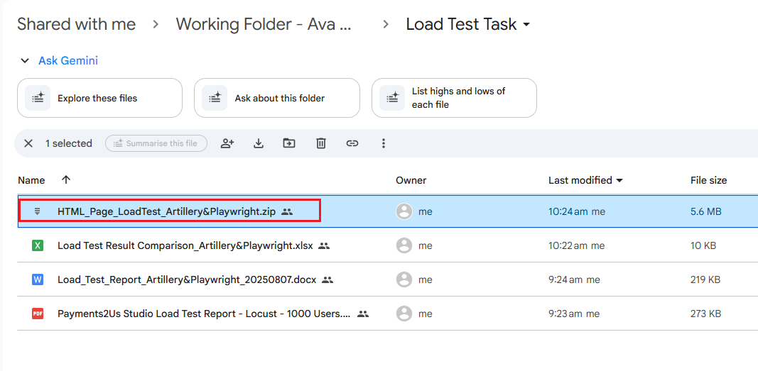

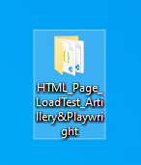

**2. Open in IDE**: Launch your preferred Integrated Development Environment (IDE), such as VS Code. From the top menu, click **File -> Open Folder**, then select the folder you just unzipped and click **Select Folder**.

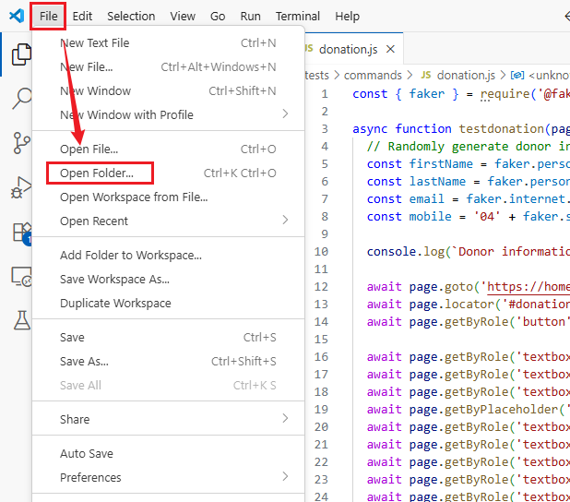

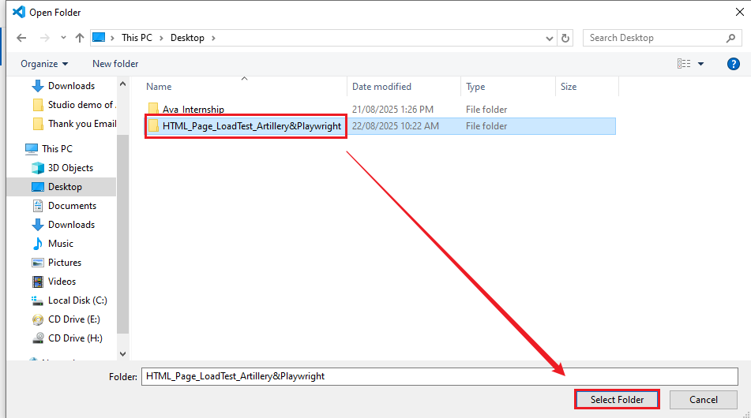

# Step 2: Understanding the Key Script Files

Inside the project, two files are crucial for our test:

1. **User Action Script (donation.js)**
   * **Path**: tests/commands/donation.js
   * **Purpose**: This script uses Playwright to simulate real user actions, like clicking buttons or filling out forms. You can easily add or remove steps in this file to match your testing needs.

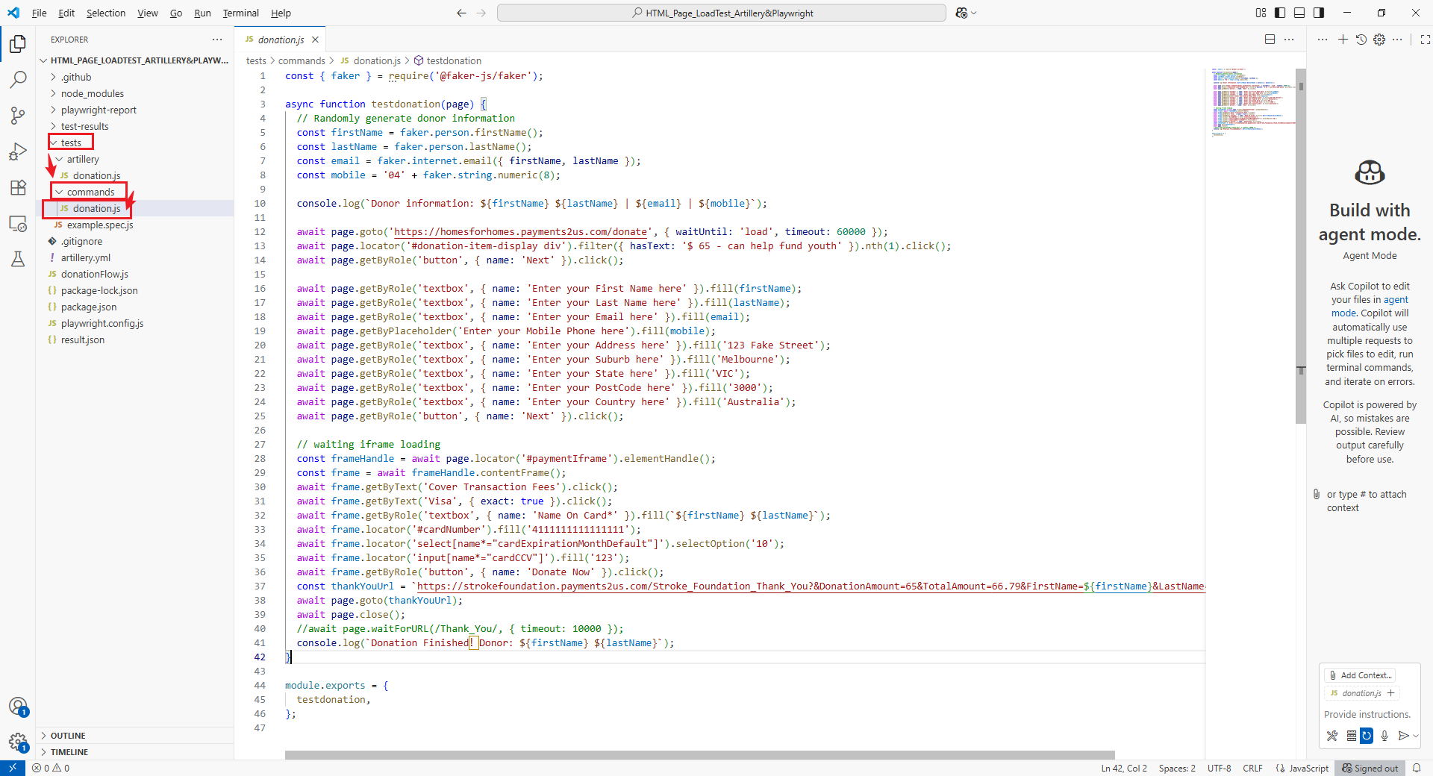

1. **Load Test Configuration (artillery.yml)**
   * **Purpose**: This is the main configuration file for Artillery. It defines all the parameters for the load test.

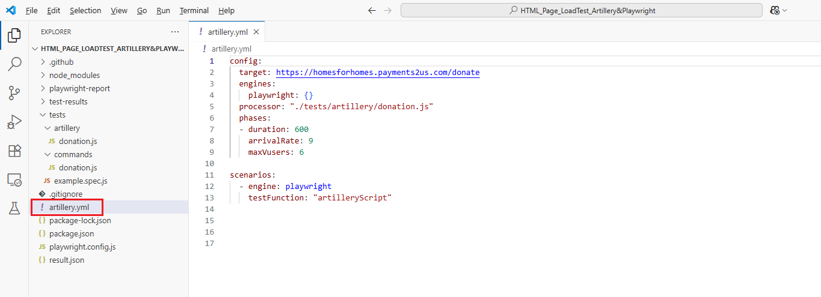

Open the artillery.yml file. You will need to modify the following key fields based on your specific testing scenario:

* target: The URL of the website you intend to test.
* duration: The total planned duration for the load test, measured in seconds. For example, a value of 600 means the test will run for 600 seconds (10 minutes).
* arrivalRate: The number of new virtual users created every second. This controls how quickly the load increases.
* maxVusers: The maximum number of virtual users that can be active on the site at any given moment.

# Step 3: Setting Up Artillery Cloud (for Test Reports)

To automatically upload your test results and generate intuitive reports, we need to set up an Artillery Cloud account.

**1.Get Your API Key**: Please follow <https://www.artillery.io/docs/get-started/artillery-cloud> to sign up for an account.

**2.Copy the API Key**: After logging in, navigate to the **API Keys** section in your account settings and copy your unique API Key.

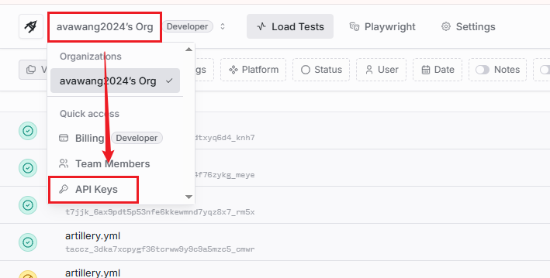

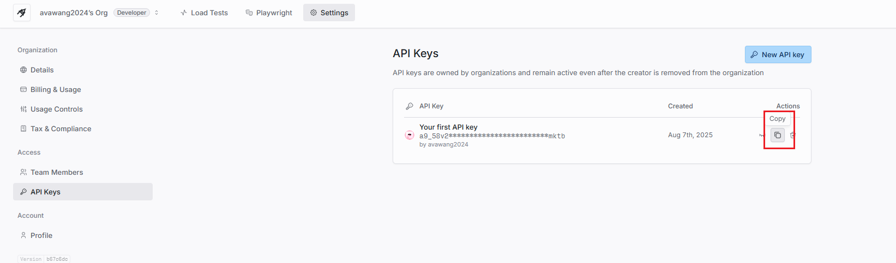

# Step 4: Running the Load Test

1. **Open a New Terminal**: Return to your IDE (e.g., VS Code) and open a new terminal window by clicking **Terminal -> New Terminal** from the top menu.

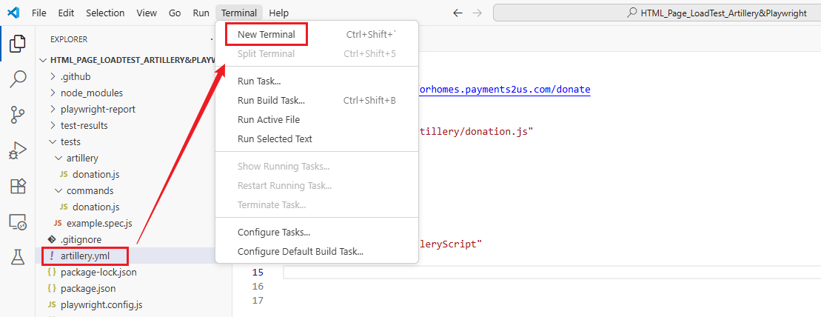

1. **Enter the Command**: In the terminal, type the following command. Remember to replace [Your_API_Key] with the API Key you just copied from Artillery Cloud.

artillery run artillery.yml --record --key [Your_API_Key]

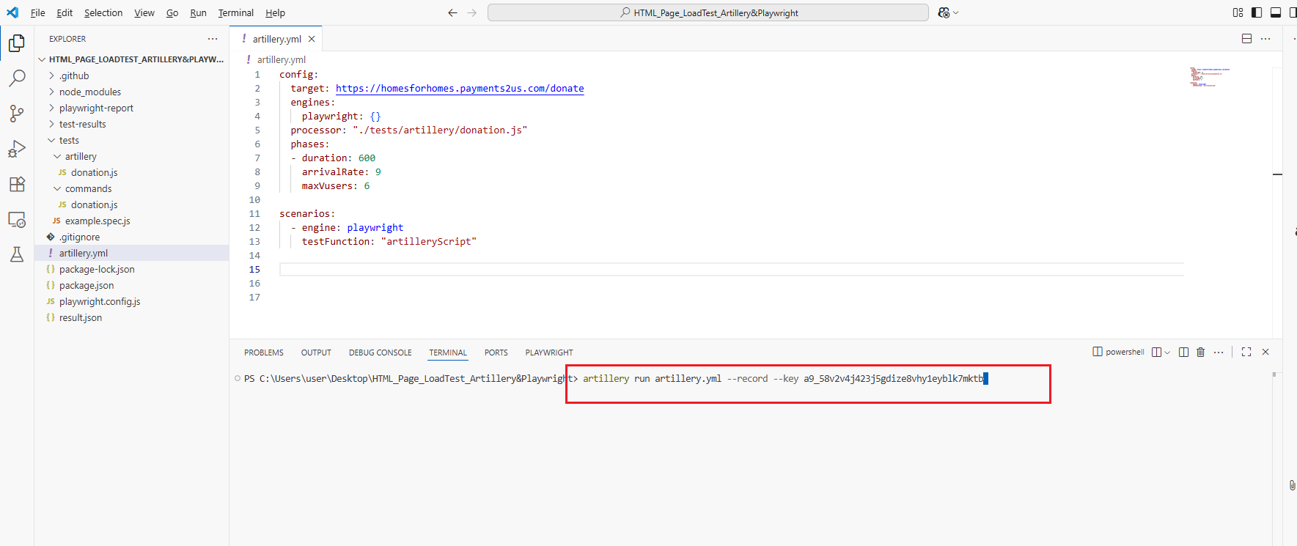

1. **Start the Test**: Press Enter. The test will begin, and the terminal will first display the **Test run id**. You will then see live updates as the test progresses and virtual users are created.

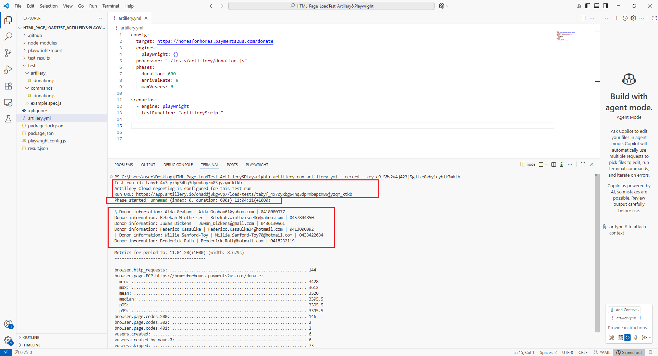

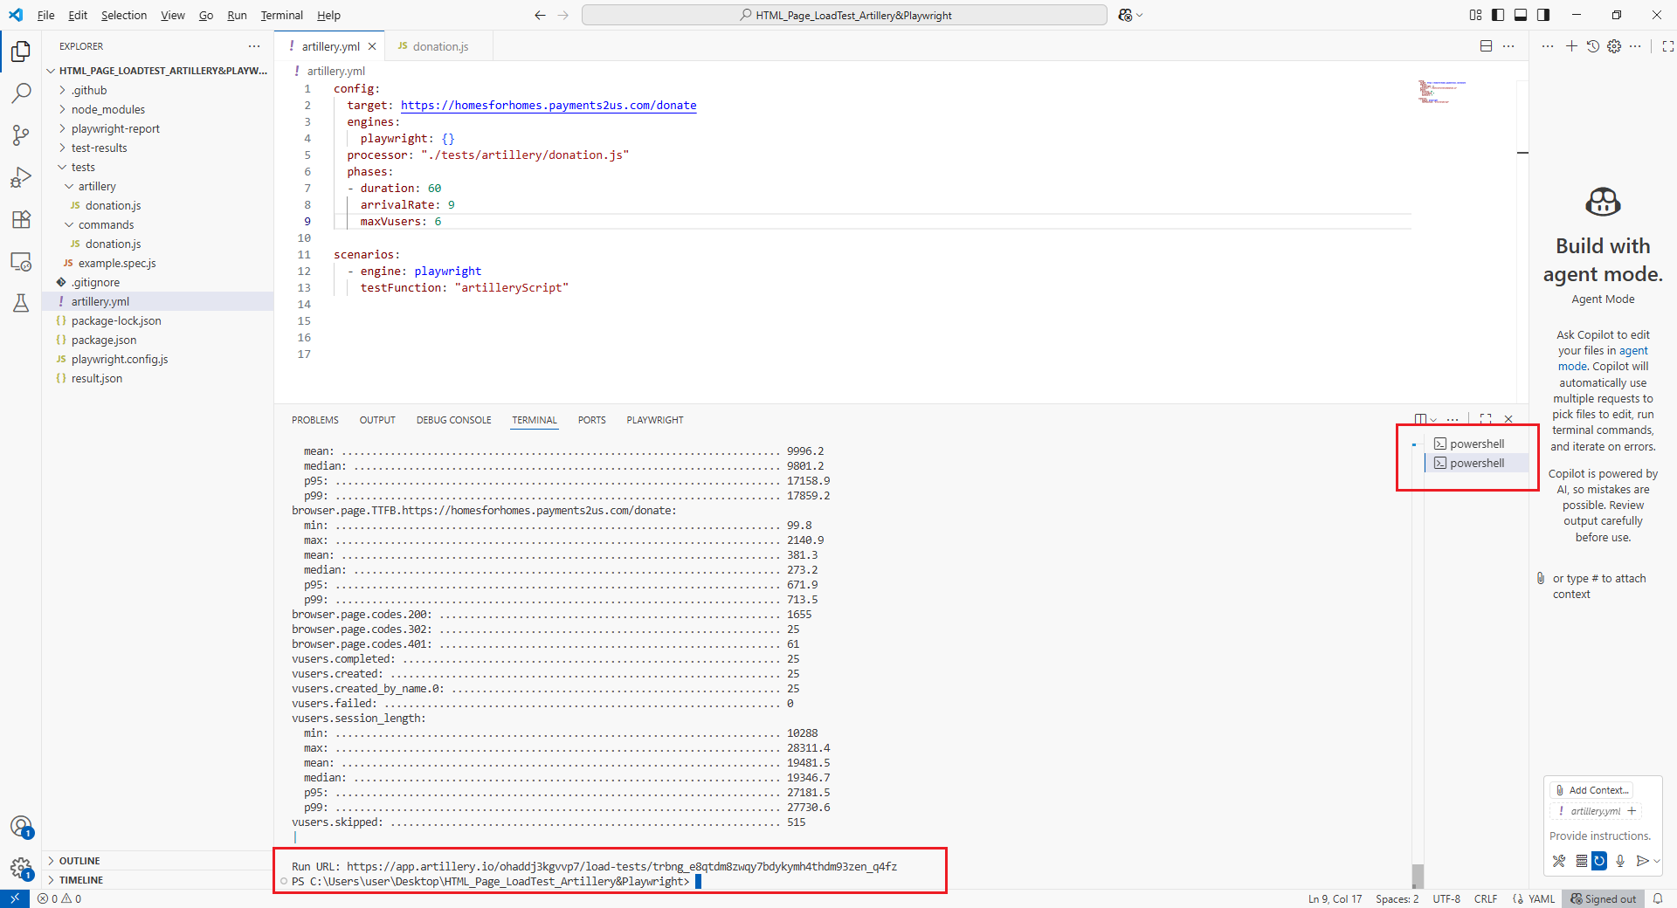

# Step 5: Viewing the Test Report

Once the test is complete, you can view a detailed report in your Artillery Cloud account.

1. **Find the Test Run**: Log in to your Artillery Cloud organization. Locate the test run using the **Test run id** shown earlier in the terminal or by the time of execution, and click on it.
2. **Analyze the Report**:
   * **Overview Tab**: This tab provides a high-level summary of the test, including its ID, time, duration, test parameters, total requests, and page performance metrics.

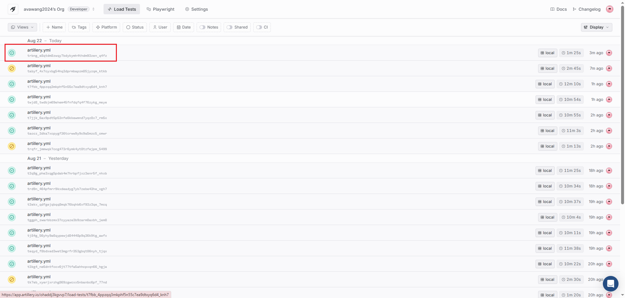

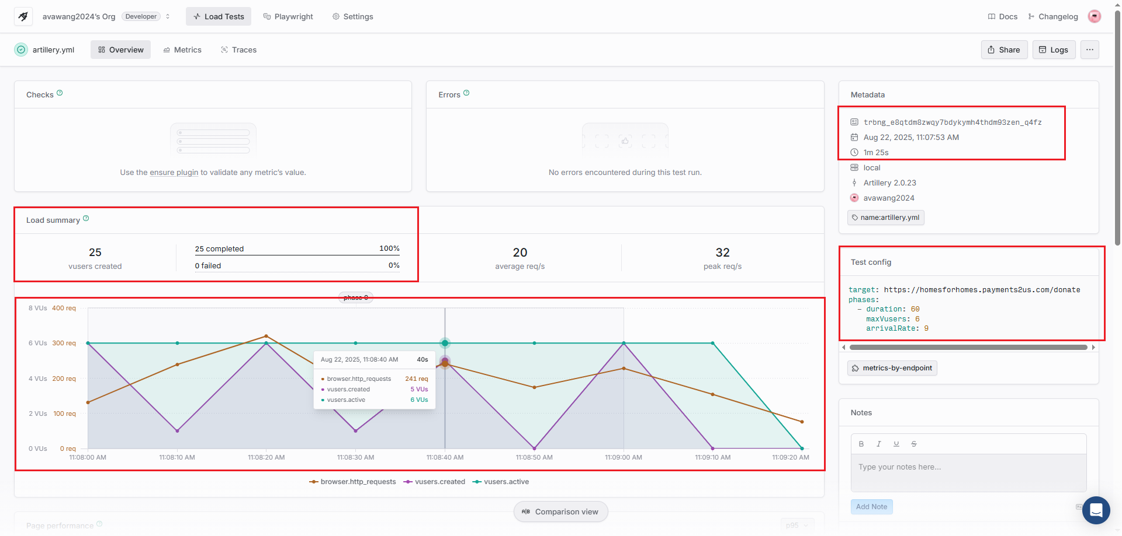

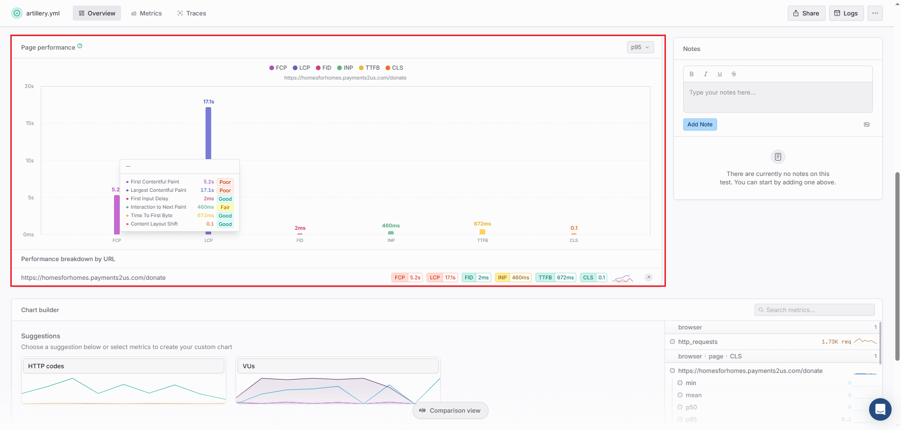

* + **Metrics Tab**: This tab offers more detailed analytical data, allowing you to dive deeper into your website's performance under stress.

